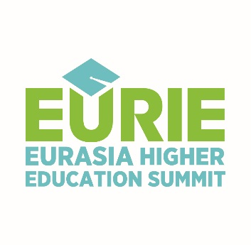

EURIE TRAINING WORKSHOP
November 3, 2017
Dimitrie Cantemir Christian University
Bucharest, Romania

Workshop Title
“Dual Aspects of Internationalization: Internationalization Across Borders and At Home”

Target audience
Professional Development Module for academic and administrative staff of higher education institutions involved in international education

Objectives
To update our knowledge of internationalization of higher education, its different aspects and instruments; to share ideas, experiences and best practices with peers; identify instruments that work effectively at your own institution

Content
Some of topics to be covered are: definition, benefits and dimensions of internationalization of higher education; mobility of students, teaching staff and researchers; internationalization of curriculum; internationalizing the campus

Language
English

Trainer
Ayse Deniz Ozkan is an international education professional (13 years), with previous experience in Erasmus, exchange and summer programs, marketing and recruitment, and international student services. She is currently Vice-Director responsible for Global Education and Partnerships at Istanbul Aydin University. She is also the coordinator for the conference program of EURIE Eurasia Higher Education Summit.

Workshop Venue
Dimitrie Cantemir Christian University, Bucharest
Splaiul Unirii, no. 176, sector 4, Bucharest, Romania
Conference Room 130, second floor
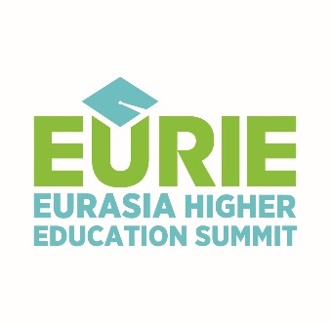

EURIE TRAINING WORKSHOP
REGISTRATION FORM

PERSONAL INFORMATION
Name and Surname:
Institution:
Position and Department:
E-mail: Mobile number:

PRIOR EXPERIENCE IN INTERNATIONALIZATION, IF ANY

OTHER TRAINING EXPERIENCE, IF ANY

YOUR EXPECTATIONS FROM THE TRAINING WORKSHOP

Please fill in and return this registration form to ramona.mihaila@ucdc.ro
by October 1, 2017.

