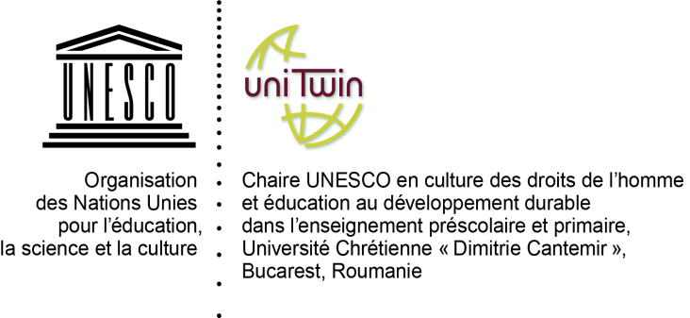 | UNIVERSITATEA CREŞTINĂ „DIMITRIE CANTEMIR”  BUCUREŞTI, SPLAIUL UNIRII NR.176 SECTOR 4  TEL. 021.330.79.00; 021.330.84.90; FAX 021.330.87.74  E-mail: office@ucdc.ro

Dear Sir / Madam,

It is with great pleasure to cordially invite you to the Conference on Creativity and Innovation from the Sustainable Development Education Perspective, organized by the UNESCO Chair Culture des droits de l’homme et éducation au développement durable dans l’enseignement préscolaire et primaire, Faculty of Education of the Dimitrie Cantemir Christian University, to be held in Romania, Bucharest, in April, 4 - 6, 2019.
The Conference activity will consist of keynotes speeches, panels and round tables on three topics:
- Agenda 2030: Objectives in action
- Practice, innovation and creativity in school
- Environnement and Sustainable Development: the professions of the future
Registration forms will be submitted by March 1 st, 2019, and full papers should be sent to the contact persons’ e-mail addresses, by March 30, 2019.
You may find enclosed the participation form.
The Dimitrie Cantemir Christian University will cover conference expenses, papers expenses and two coffee breaks.
We are looking forward to meeting you at the Conference on April, 4-6, 2019 to exchange fruitful ideas, socialize, and take nice memories back home.

Sincerely yours,
Octavia Costea, Ph.D, professor
Conona Petrescu, PhD, senior lecturer
UNESCO Chair
Faculty of Education

Corina-AdrianaDumitrescu,  Ph.D, professor  President of the Dimitrie Cantemir Christian University Senate | Cristiana Cristureanu,  PhD, professor  Rector of the Dimitrie Cantemir  Christian University

